Year 12 Chemistry Topic Test # 2 (Bonding) - 2012

Name: ANSWERS

Part 1: Multiple Choice Section 10 marks
_____________________________________________________________________________

1. D 2. C 3. A 4. B 5. C 6. B 7. A 8. C 9. B 10. B each

Part 2: Short Answer Section 34 marks
_____________________________________________________________________________

1. Nitrogen (N₂) exists is a gas at room temperature. Nitrogen trichloride (NC₃) exists as a
liquid at room temperature.

(a) Name the bonding that would exist in a container of each substance giving
reasons for your answer.

N₂ N-N bonds are covalent

Intermolecular bonding is dispersion forces only as N₂ molecules
are non-polar
NC₃ N-C bonds are covalent

Intermolecular bonding is dipole-dipole and dispersion forces
– dipole-dipole because molecule is polar
− dispersion forces because they occur between all particles
(5 marks)

2. Complete the following table:

Species | Electron dot diagram | Name of shape | Polarity  (polar or non-polar)
SO₂ | 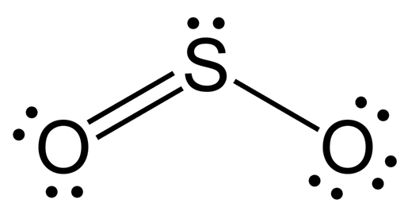 | bent | polar
HCN |  | linear | polar
SO₄²⁻ | 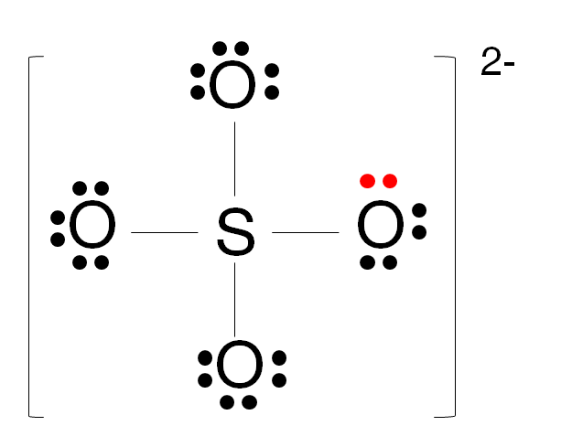 | tetrahedral | N/A
PI₃ | 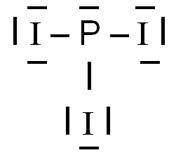 | pyramidal | polar

(11 marks)

3. The following table gives some information about three elements in the fourth row of the
Periodic Table.

Element | Electrical conductivity  (MS m^{–1}) | First ionisation energy  (kJ mol⁻') | Melting point  (°C)
Potassium | 14 | 425 | 63
Calcium | 29 | 596 | 650
Germanium | 1 x 10⁻⁴ | 762 | 938

(a) What type of bonding would you expect to occur in germanium?

covalent network
(1 mark)
(b) Justify your answer.

Poor electrical conductor, so can’t be metallic

High melting point, so can’t be molecular

Obviously not ionic, so ∴ covalent network
(3 marks)

(c) Explain the trend in ionisation energies of the elements above.

Increasing nuclear charge (from K to Ca to Ge), with a similar degree of
shielding

∴ more energy required to remove e⁻ from Ge than Ca than K.
(1 mark)

(d) Would the value of potassium’s second ionisation energy be larger or smaller than
that for calcium? Explain why.

Larger

The removal of 2nd e⁻ from Ca is from the same (fourth) shell,
whereas K is from the third shell – less shielding, ∴ more strongly
attracted and more energy required

(2 marks)

4. Use your understanding of atomic structure and bonding to:

(a) Complete a sketch showing the boiling points of the hydrides of group 14 (———)
and group 17 (- - - - -) on the following graph.

2
3
4
5
Melting
Point

Period Number

mp of group 14 hydrides increasing
mp of group 17 hydrides higher than group 14
mp of group 17 hydrides increasing from period 3 to period 5
mp of group 17 hydride in period 2 (HF) higher than period 3
(4 marks)

(b) Explain the overall trend shown on the graph:

Increasing mp with increasing size of molecules

This is due to increasing strength of dispersion forces with increasing
size of molecule, as temporary dipoles become larger
(2 marks)

(c) Give reasons for any exceptions to this trend.

HF has a particularly strong form of dipole-dipole attraction, called
hydrogen bonding.

This arises due to the great difference in electronegativity between
H and F and the small size of F.
(1 mark)

5. Using your knowledge of atomic structure and bonding explain the following physical data:

Substance | Solubility in water at 25°C (g L⁻¹)
1-pentanol  (CH₃CH₂CH₂CH₂CH₂OH) | 22.0
1-hexanol  (CH₃CH₂CH₂CH₂CH₂CH₂OH) | 5.9

Water is polar molecule and contains with dispersion forces and hydrogen
bonding between molecules.

Hydrogen bonding also exists between molecules of each alcohol, but
dispersion forces become more significant as the molecule becomes
larger (as the carbon chain increases in length).

Only dispersion forces form between the carbon chain and water, which
are much weaker than hydrogen bonds between water and dispersion
forces between alcohols.

As the alcohol size increases, solubility in water decreases.

(4 marks)

End of Test

